Туякбаева Бақнұр Айдарбекқызы - ведущий специалист Лаборатории №2
РГП «КазСтандарт»; bakhnur@dos@gmail.com
Жумағали Асылбек Қайратұлы – главный специалист Лаборатории №2
РГП «КазСтандарт», a.zhumagali@ksm.kz
Киргизбаева Камиля Жузбаевна кандидат наук, ассоциированный профессор
ЕНУ им. Л.Н. Гумилева

Topic: "Current status of metrological traceability of non-contact temperatures"

Аннотация. В статье рассматривается текущее состояние метрологической прослеживаемости средств измерений температуры в бесконтактном режиме в Республике Казахстан. Проанализированы структура и метрологические характеристики Государственного рабочего эталона температуры по бесконтактному излучению в диапазоне от −30 °C до 2500 °C, созданного в 2004 году на базе РГП «КазСтандарт». Выявлены основные проблемы существующей системы метрологического обеспечения, связанные с отсутствием первичного эталона и зависимостью от зарубежных калибровок. Обоснована необходимость создания первичного эталона на основе современных излучателей типа «абсолютно чёрное тело» с применением металлических и эвтектических реперных точек для обеспечения прослеживаемости к Международной температурной шкале (МТШ-90) во всём диапазоне измерений. Предложены технические решения по модернизации эталонной базы, включающие использование высокоточного оборудования и расширенного набора реперных точек.
Ключевые слова: метрологическая прослеживаемость, бесконтактная термометрия, государственный рабочий эталон, МТШ-90, эвтектические сплавы.

Аңдатпа. Мақалада Қазақстан Республикасындағы контактісіз режимдегі температураны өлшеу құралдарының метрологиялық қадағалануының қазіргі жағдайы қарастырылады. 2004 жылы «ҚазСтандарт» РМК базасында құрылған, −30 °C-тан 2500 °C-қа дейінгі диапазонды қамтитын контактісіз сәулелену бойынша температураның Мемлекеттік жұмыс эталонының құрылымы мен метрологиялық сипаттамалары талданған. Бірінші эталонның болмауы және шетелдік калибрлеуге тәуелділікпен байланысты қолданыстағы метрологиялық қамтамасыз ету жүйесінің негізгі мәселелері анықталған. Өлшеу диапазоны бойынша Халықаралық температура шкаласына (ХТШ-90) қадағалануды қамтамасыз ету мақсатында металдық және эвтектикалық реперлік нүктелерді пайдалана отырып, заманауи «абсолют қара дене» типті сәулелендіргіштер негізінде бірінші эталон құрудың қажеттілігі негізделген. Жоғары дәлдіктегі жабдықты және реперлік нүктелердің кеңейтілген жиынтығын қолдануды қамтитын эталондық базаны жаңғырту бойынша техникалық шешімдер ұсынылған.
Түйінді сөздер: метрологиялық қадағалау, контактісіз термометрия, мемлекеттік жұмыс эталоны, ХТШ-90, эвтектикалық қорытпалар.
Annotation: The article examines the current state of metrological traceability of non-contact temperature measuring instruments in the Republic of Kazakhstan. The structure and metrological characteristics of the State Working Standard for non-contact radiation thermometry, covering the range from −30 °C to 2500 °C and established in 2004 at RSE "KazStandard", are analysed. Key shortcomings of the existing metrological assurance system are identified, primarily the absence of a primary standard and dependence on foreign calibrations. The necessity of establishing a primary standard based on modern absolute blackbody radiators, incorporating metallic and eutectic fixed points, is substantiated to ensure full traceability to the International Temperature Scale (ITS-90) across the entire measurement range. Technical solutions for modernising the reference base are proposed, including the adoption of high-precision instrumentation and an extended set of fixed-point cells.
Keywords: metrological traceability, non-contact thermometry, state working standard, ITS-90, eutectic alloys.

Introduction. The problem of metrological traceability of non-contact temperature measurements in Kazakhstan has not yet received adequate coverage in the scientific literature.
The relevance of the study is determined by the following factors. Firstly, according to the requirements of ILAC and BIPM, each state must ensure the traceability of measurements through its own reference system [1]. Secondly, the development of metallurgy, energy and oil and gas processing in Kazakhstan requires high-precision temperature control up to 2500°C.
Despite the existence of the State Working Standard (SWS), in RSE «KazStandart» currently lacks a primary standard for contactless thermometry, which creates certain limitations in the country's metrological support. In this regard, the measuring instruments included in the SWS are sent for calibration to foreign national metrological institutes, which entails additional financial costs, time costs and a certain dependence on external metrological services. The state working temperature standard for non-contact radiation in the range from minus
30 °C to 2500 °C (registration number in the registry of the State system for ensuring the uniformity of measurements of the Republic of Kazakhstan KZ.01.02.00038-2020), is designed to store a unit of temperature and transfer its size to working standards of the 2nd category and working measuring instruments in accordance with ST RK 2.25-2013 «The state standard and the state verification scheme for temperature measuring instruments», and was created in 2004 on the basis of the South Kazakhstan branch RSE «KazInMeter».
The action of the emitters, which are the main part of the SWS, is based on the fact that the radiating cavity, made in the form of an absolute blackbody model, corresponds to the thermal radiation density value of Planck's law. The radiator includes a thermal radiator, connecting cables, and a precision pyrometer that performs the function of a feedback sensor.
The composition of SWS is shown in Table 1.

Table 1
№ | Name and type | Manufacturer | Measuring range | Error
1 | Pyrometer ПД-9-02 | JSC «Nauchno-proizvodstvennoe predpriatie Etalon», Russian Federation | from 400 °C to 1400 °C | (0,0028 t + 0,5) ºС
2 | Pyrometer ПД-4-06 |  | from 1200 °C to 2500 °C | 0,2 % of the range
3 | The radiator ПЧТ -540/40/100 |  | from 30 °C to 95 °C | ± 0,15 °C
4 | The radiator АЧТ-30/900/2500 |  | from 900 °C to 2500 °C | not more than ± 2,5 °C
5 | Pyrometer Optris LS DCL | Optris GmbH, Germany | from minus 35 °C to 900 °C | not more than ± 2,5 °C
6 | Portable Infrared Calibrator Fluke 9133 | Fluke Calibration, USA | from minus 30 °С to 150 °С | ±0,4°С
7 | Blackbody sources Medusa R 999 | the company «Isotech», Great Britain | from 30 °С to 550 °С | ±2 °C
8 | Blackbody source 878 Saturn/Cyclops | the company «Isotech», Great Britain | от 100 °С до 1300 °С | ±2 °C

Advanced equipment for the primary reference
As a basis for creating a primary standard for non-contact thermometry, it is recommended to consider a high-precision radiator in the form of a model of a completely blackbody sources «Medusa R 999», manufactured by Isotech, Great Britain with the capabilities of installing ampoules in the cavity in accordance with ITS-90 (Figures 1-2).

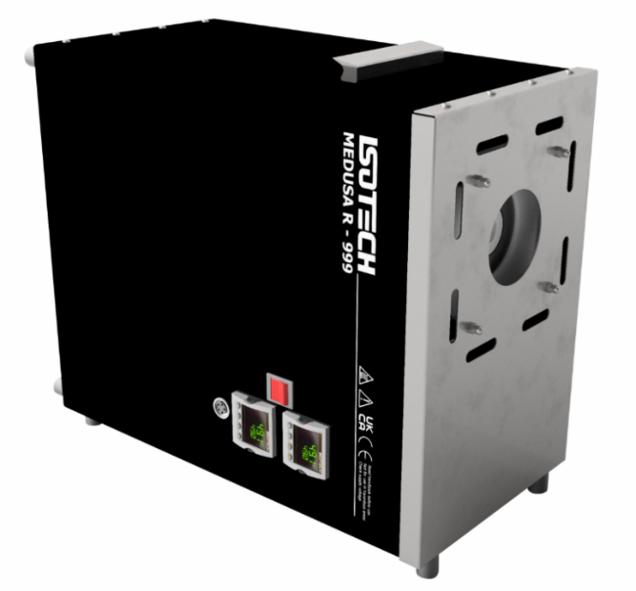 | 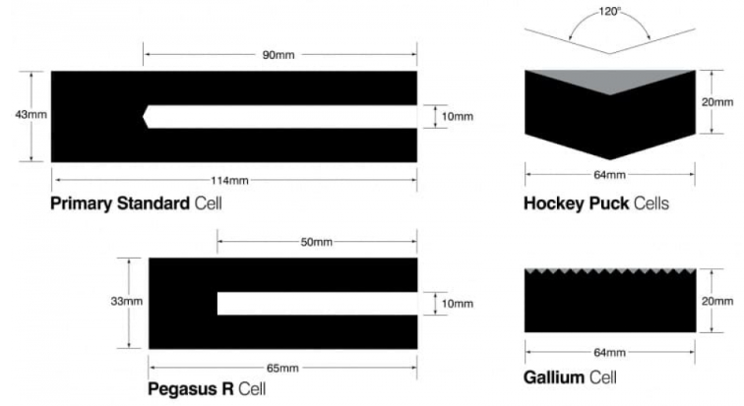
Figure 1. Blackbody sources «Medusa R 999» | Figure 2. Ampoules blackbody sources
The design features of the Medusa R 999 ensure its functioning as a highly stable source of infrared radiation with characteristics as close as possible to the theoretical blackbody. The radiating cavity of the device has optimized geometric parameters - a depth of 45 mm and a diameter of 285 mm, which makes it possible to accommodate large-sized Isotech reference cells with fixed ITS-90 points and creates conditions for achieving a high effective emissivity of the cavity (close to 0.999) [9].
The uniformity of the temperature field of the massive metal block is ensured through the use of innovative distributed heating technology, in which the heating elements are optimally positioned throughout the entire volume of the block, eliminating the formation of temperature gradients and zones of heterogeneity.
Application of eutectic alloys in high-temperature thermometry
Eutectic (from the Greek eutēktos - fusible) is a liquid solution of several components of a certain composition that crystallizes at a constant temperature as an individual substance. The eutectic temperature is characterized by high reproducibility, which makes eutectic alloys valuable reference points for calibration of high-temperature pyrometers [7].
The main eutectic reference points for the high-temperature region include: gold-copper (Au-Cu, 910.4°C), gold-palladium (Au-Pd, 1064.18°C), palladium-platinum (Pd-Pt, 1555°C), nickel-carbon (Ni-C, 1329°C), iron-carbon (Fe-C, 1154°C). In the ultrahigh-temperature range (above 2000°C), eutectic based on refractory metals are used: iridium-carbon (Ir-C, 2290°C), rhenium-carbon (Re-C, 2474°C), tungsten-carbon (W-C, above 2500°C) [8].
Modern eutectic cells are made of high purity components (99.99% or higher) with precisely controlled composition. The uncertainty of reproducing the solidification temperature is: ±0.1-0.5°C in the range of 900-1500°C; ±0.5-1.5°C in the range of 1500 - 2000°C; ±1.0-3.0°C in the range of 2000 - 2500°C [9].
Ampoules with eutectic drugs can be installed in the AСHT-30/900/2500 radiator. However, commercial organizations are not engaged in the development of ampoules with eutectic drugs, but only scientific institutes produce them, which creates a high cost of this ampoule.
Conclusion. To minimize errors and economic losses, as well as to ensure traceability of measurements to the ITS-90, the Medusa R radiator can be used in conjunction with certified Isotech reference cells containing high-purity metals with precisely defined phase transition temperatures. The following main reference points of the MTSH-90 are available in the range of operation of the device:
- Indium (In) - solidification temperature 156,5985 °C
- Tin (Sn) - solidification temperature 231,928 °C
- Zinc (Zn) - solidification temperature 419,527 °C
The creation of a primary standard for contactless thermometry based on modern equipment with the implementation of ITS-90 is a strategically important step in the development of the national metrological system of the Republic of Kazakhstan. This will ensure the country's metrological independence, improve the quality of calibration services, reduce the time and cost of metrological support for measuring instruments, and create conditions for the development of high-tech industries and scientific research.

References:
1. Preston-Thomas H. The International Temperature Scale of 1990 (ITS-90) // Metrologia. 1990. Vol. 27. P. 3–10. DOI: 10.1088/0026-1394/27/1/002.
2. Fu T., Zhao Y., Shi C., Ma C. Review of radiation thermometry methods and applications in industrial processes // Measurement Science and Technology. 2022. Vol. 33. Article 102001. DOI: 10.1088/1361-6501/ac75fb.
3. Mendes L.B., Honorato H.A., Ribeiro J.E., Godoy S. Modulated thermoreflectance microscopy for non-contact temperature measurements // Review of Scientific Instruments. 2022. Vol. 93. Article 034903. DOI: 10.1063/5.0079909.
4. JCGM 100:2008. Evaluation of measurement data — Guide to the expression of uncertainty in measurement (GUM). BIPM, 2008. URL: https://www.bipm.org/documents/20126/2071204/JCGM_100_2008_E.pdf.
5. JCGM 200:2012. International vocabulary of metrology — Basic and general concepts and associated terms (VIM). BIPM, 2012. URL: https://www.bipm.org/documents/20126/2071204/JCGM_200_2012.pdf.
6. СТ РК 2.25-2013. Государственный эталон и государственная поверочная схема для средств измерений температуры. — Астана: КазИнМетр, 2013.
7. Yamada Y., Wang Y., Sasajima N. Recent progress in metal carbide–carbon eutectic fixed-point cells for contact thermometry // Metrologia. 2023. Vol. 60. Article 012001. DOI: 10.1088/1681-7575/ac9d43.
8. Girard F., Greenen E. [фамилию уточнить по оригиналу]. Characterization of palladium-carbon and platinum-carbon eutectic fixed-point cells // International Journal of Thermophysics. 2022. Vol. 43. Article 145. DOI: уточнить на link.springer.com/journal/10765.
9. Sasajima N., Yamada Y. High-temperature fixed points in the range 1150 °C to 2500 °C using metal-carbon eutectics // Metrologia. 2016. Vol. 53. — Уточнить страницы по iopscience.iop.org/journal/0026-1394, vol. 53.
10. CCT-WG5 (Consultative Committee for Thermometry — Working Group 5). Mise en pratique for the definition of the kelvin in the SI. BIPM, 2021. URL: https://www.bipm.org/documents/20126/41489682/SI-App2-kelvin.pdf.
11. Isothermal Technology Ltd. Medusa-R Model 999 [Electronic resource]. URL: https://isotech.co.uk/products/medusa-r-model-999/ (accessed: 5 March 2026).

