Ж.М.Мергенова, Восточно-Казахстанский филиал РГП “КазСтандарт”, г.Усть-каменогорск, Казахстан, zhansaya.mergenova@gmail.com
МЕТОДОЛОГИЧЕСКИЕ АСПЕКТЫ АТТЕСТАЦИИ ПЕРВИЧНЫХ СТАНДАРТНЫХ ОБРАЗЦОВ ОРГАНИЧЕСКИХ ВЕЩЕСТВ: ПОДХОД НА ОСНОВЕ МАТЕРИАЛЬНОГО БАЛАНСА
Аннотация Данная работа посвящена анализу современных метрологических подходов к обеспечению единства измерений в органической химии. Вступительное слово касается критической важности точности калибровочных материалов для работы аккредитованных лабораторий. Целью исследования является систематизация методологии аттестации первичных стандартных образцов (ГСО) с использованием метода материального баланса (Mass Balance). Научная и практическая значимость работы заключается в детальном описании алгоритма создания эталонов высшего порядка, обеспечивающих прямую прослеживаемость к единицам системы СИ. Методология исследования базируется на анализе передового опыта Национального института метрологии Южной Кореи (KRISS) и анализе требований международного стандарта ISO 17034. В работе рассмотрен комплексный аналитический подход, включающий ВЭЖХ-УФ, титрование по Карлу Фишеру, газовую хроматографию и термогравиметрию. Основные результаты и анализ данных на примере фолиевой кислоты подтверждают, что метод материального баланса, дополненный количественным ЯМР, позволяет достичь минимальной неопределенности. Ценность исследования заключается в формировании единого методического подхода к характеризации чистоты органических веществ. Практическое значение итогов работы состоит в возможности использования данных алгоритмов для разработки национальных стандартных образцов и повышения достоверности химико-аналитических измерений.
Ключевые слова: метрологическая прослеживаемость, первичный стандартный образец, метод материального баланса, фолиевая кислота, неопределенность измерений, KRISS, ISO 17034.

Zh. Mergenova, East-Kazakstan Branch RSE “KazStandart”, Oskemen city, Kazakhstan, zhansaya.mergenova@gmail.com
METHODOLOGICAL ASPECTS OF THE CERTIFICATION OF PRIMARY REFERENCE MATERIALS OF ORGANIC SUBSTANCES: A MATERIAL BALANCE–BASED APPROACH
Abstract This paper analyzes modern metrological approaches to ensuring the uniformity of measurements in organic chemistry. The introductory remarks address the critical importance of calibration material accuracy for the operation of accredited laboratories. The aim of the study is to systematize the methodology for certifying primary reference materials (PRMs) using the mass balance approach. The scientific and practical significance of the work lies in the detailed description of the algorithm for creating high-order standards that ensure direct traceability to SI units. The methodology of the study is based on the analysis of the advanced experience of the Korea Research Institute of Standards and Science (KRISS) and the requirements of the international standard ISO 17034. The paper considers a comprehensive analytical approach, including HPLC-UV, Karl Fischer titration, gas chromatography, and thermogravimetry. The main results and data analysis using folic acid as an example confirm that the mass balance method, supplemented by quantitative NMR, achieves minimal uncertainty. The value of the study lies in the formation of a unified methodological approach to the characterization of the purity of organic substances. The practical significance of the results consists in the possibility of using these algorithms for the development of national reference materials and increasing the reliability of chemical-analytical measurements.
Keywords: metrological traceability, primary reference material, mass balance approach, folic acid, measurement uncertainty, KRISS, ISO 17034.

Ж.М.Мергенова, Шығыс Қазақстан филиалы РГП “КазСтандарт”, Өскемен қ., Қазақстан, zhansaya.mergenova@gmail.com
ОРГАНИКАЛЫҚ ЗАТТАРДЫҢ БІРІНШІЛІК СТАНДАРТТЫ ҮЛГІЛЕРІН АТТЕСТАТТАУДЫҢ ӘДІСТЕМЕЛІК АСПЕКТІЛЕРІ: МАТЕРИАЛДЫҚ БАЛАНСҚА НЕГІЗДЕЛГЕН ТӘСІЛ
Аңдатпа Бұл жұмыс органикалық химиядағы өлшем бірлігін қамтамасыз етудің заманауи метрологиялық тәсілдерін талдауға арналған. Кіріспе сөз аккредиттелген зертханалардың жұмысы үшін калибрлеу материалдары дәлдігінің маңыздылығына тоқталады. Зерттеудің мақсаты — материалдық баланс (Mass Balance) әдісін қолдана отырып, біріншілік стандартты үлгілерді (БСҮ) аттестаттау әдістемесін жүйелеу. Жұмыстың ғылыми және практикалық маңыздылығы СИ жүйесінің бірліктеріне тікелей қадағалануды қамтамасыз ететін жоғары ретті эталондарды жасау алгоритмін егжей-тегжейлі сипаттауда жатыр. Зерттеу әдістемесі Оңтүстік Кореяның Ұлттық метрология институтының (KRISS) озық тәжірибесін және ISO 17034 халықаралық стандартының талаптарын талдауға негізделген. Жұмыста ЖҚХ-УФ, Карл Фишер бойынша титрлеу, газдық хроматография және термогравиметрияны қамтитын кешенді талдау тәсілі қарастырылған. Фолий қышқылы мысалындағы негізгі нәтижелер мен мәліметтерді талдау сандық ЯМР-мен толықтырылған материалдық баланс әдісі минималды белгісіздікке қол жеткізуге мүмкіндік беретінін растайды. Зерттеудің құндылығы органикалық заттардың тазалығын сипаттаудың бірыңғай әдістемелік тәсілін қалыптастыруда. Жұмыс нәтижелерінің практикалық маңызы осы алгоритмдерді ұлттық стандартты үлгілерді әзірлеу және химиялық-талдау өлшемдерінің сенімділігін арттыру үшін пайдалану мүмкіндігінде.
Түйін сөздер: метрологиялық қадағалану, біріншілік стандартты үлгі, материалдық баланс әдісі, фолий қышқылы, өлшеу белгісіздігі, KRISS, ISO 17034.

INTRODUCTION (ВВЕДЕНИЕ)
The accuracy and comparability of chemical analysis results are priority tasks in modern metrology. At the core of measurement quality assurance is the concept of metrological traceability. To implement this concept, reference materials (RMs) are required whose certified values are linked to the fundamental units of the SI system—the mole and the kilogram.
Primary Reference Materials (PRMs) hold a special place in this hierarchy. PRMs are materials of the highest metrological quality, established using primary methods rather than comparison with other samples. For organic compounds, this task is complicated by their chemical nature: the presence of isomers, hygroscopicity, and residual solvents from synthesis processes.
This article discusses the methodological aspects of PRM certification based on the experience of KRISS (Korea Research Institute of Standards and Science). KRISS is the national metrology institute of the Republic of Korea and a global leader in purity analysis. Studying their approaches allows for the systematization of requirements for modern analytical production of standards.
METHODS AND MATERIALS (МЕТОДЫ И МАТЕРИАЛЫ)
The methodological basis of the study is the Mass Balance Approach. The essence of this approach is the "indirect" determination of purity: instead of measuring the target substance, all possible groups of impurities are measured and then subtracted from 100%.
The mathematical model for calculating the certified purity value is expressed by the equation:

P = 100% - (worg + wwater+ wsolv + winorg) | (1)

Where:
worg is the mass fraction of related organic impurities;
wwater is the total water content;
wsolv is the mass fraction of residual organic solvents;
winorg is the fraction of inorganic impurities.
To implement this method, a complex of orthogonal analytical methods is required. The characterization process of Folic Acid, a complex organic compound used in international key comparisons (CCQM), is considered as a case study.
This figure illustrates the hierarchical structure of metrological traceability, which links everyday laboratory measurements to the fundamental units of the International System of Units (SI). At the top of the hierarchy are primary methods and national standards, which ensure the transfer of measurement units through certified reference materials down to working standards used in laboratories. This continuous chain of calibrations and comparisons minimizes measurement uncertainty and guarantees the international equivalence and recognition of analytical results.

Hierarchical structure of metrological traceability in organic analysis in figure 1.

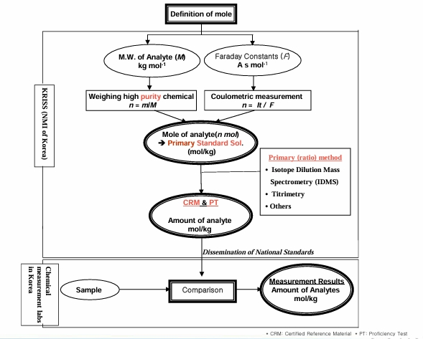
Figure – 1 Hierarchical structure of metrological traceability in organic analysis

Below Analytical Complex for the Mass Balance Approach in table 1.

Table 1. Analytical Complex for the Mass Balance Approach

Impurity Class | Measurement Method | Role in Methodology
Organic Impurities | LC-UV (HPLC-UV) | Identification of structural analogs
Water Content | Karl Fischer Titration | Determination of hydrated and sorbed moisture
Volatile Substances | HS-GC/MS (Headspace GC-MS) | Analysis of synthesis solvent residues
Inorganic Residuals | TGA (Thermogravimetry) | Assessment of ash content

RESULTS AND DISCUSSION
Data analysis from KRISS regarding folic acid characterization established that the mass balance methodology requires strict accounting of uncertainty at each stage.
Organic Impurity Analysis. In HPLC-UV, the choice of detection wavelength is critical. Organic impurities may have different absorption coefficients. The KRISS methodology involves using multiple detectors or scanning a wide range of wavelengths to eliminate the risk of missing impurities.
Water Analysis. For substances like folic acid, water content can reach 8%. This makes water determination the most significant contribution to the final uncertainty budget after the main component. Using coulometric Karl Fischer titration with thermal desorption achieves reproducibility at the 0.1-0.2% level.
Purity Assay By LC-UV, Ash analysis by TGA, Residual solvents by HS-GC/MS, Water Contents by Karl-Fischer Coulometry – Quantification of main component and impurities in figure 2 and 3,4.

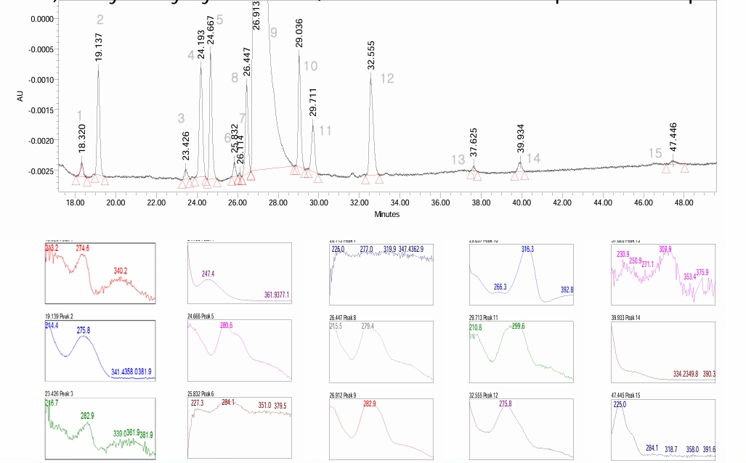

Figure – 2 Purity Assay By LC-UV – Quantification of main component and impurities

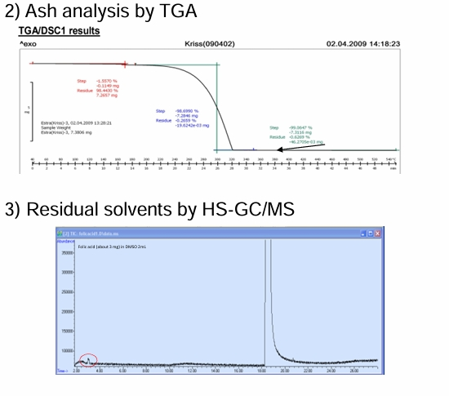
Figure – 3 Purity Assay By Ash analysis by TGA and Residual solvents by HS-GC/MS
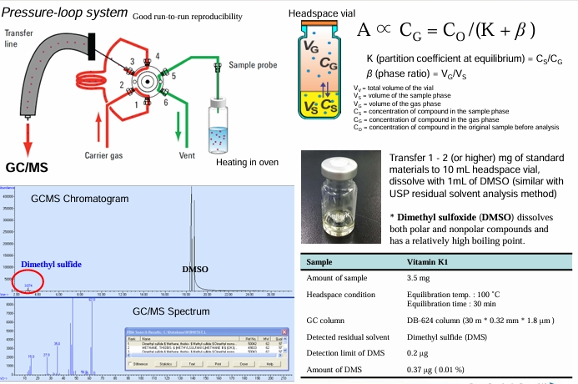

Figure – 3 - Water Contents by Karl-Fischer Coulometry

Below are the summarized results used for PRM certification in table 2.

Table 2. Component Budget in Folic Acid Characterization (KRISS Data)

Component | Mass Fraction (%) | Standard Uncertainty (u)
Organic Impurities | 91,84 | 0,03
Water (Moisture) | 7,614 | 0,07
Residual Solvents | 0,03 | 0.003
Inorganic Impurities | 0,00 | 0.005
Purity (Final) | 91,29 | 0,06

The characterization of Folic Acid was conducted following the primary method requirements for international comparisons (CCQM-K55.d). The determination of purity was based on the combination of chromatographic analysis and impurity quantification. The chromatographic purity (fc) was established at 98,84±0.03%. A significant portion of the material consisted of water, with a measured mass fraction (f_w) of 7,614±0.07\%, confirmed by Karl-Fischer coulometry. Inorganic impurities (ash) and residual volatile organic solvents were found to be minimal, contributing 0.03 and 0.00% respectively. According to the mass balance equation the final certified purity of the Folic Acid reference material was calculated as 91,29 ± 0.06%. A vital part of the discussion is the validation of obtained data. In modern metrology, quantitative NMR (qNMR) is used for this purpose. Unlike mass balance, qNMR is a direct method, as the resonance intensity is directly proportional to the number of hydrogen nuclei in the molecule.

Comparison of Primary Methods in table 3.

Table 3. Comparison of Primary Methods (Validation)

Method | Purity Result (%) | Expanded Uncertainty  (k=2)
Mass Balance Method | 91,29 | 0,06
qNMR Method | 91,61

The agreement of the results confirms that no systematic errors were made in the mass balance method and all significant impurities were accounted for.

CONCLUSION
Based on the analyzed methodological aspects, the following conclusions can be drawn:
1. The mass balance approach is the most robust framework for establishing metrological traceability of organic substances to SI units.
2. The key condition for certification validity is the use of complementary analytical methods covering all impurity classes.
3. KRISS experience shows that PRM status requires independent validation by an orthogonal method like qNMR.

REFERENCES
1. ISO 17034:2016. General requirements for the competence of reference material producers. — Geneva: ISO, 2016.
2. Kim B. Practical Approach for Establishing National Standards in Organic Analysis. — Daejeon: KRISS, Global Metrology Academy, 2024.
3. Choi K. Overview of Organic Analysis Laboratory. — Daejeon: Organic Metrology Group, KRISS, 2024.
4. Eurachem/CITAG Guide. Quantifying Uncertainty in Analytical Measurement. — 3rd Ed. — 2012.
5. Heo S. W. Overview of Inorganic Analysis Laboratory. — Daejeon: KRISS, 2024.

